**USING RAPTOR – DISPLAY POSITION OF NUMBERS**

**FLOWCHART**

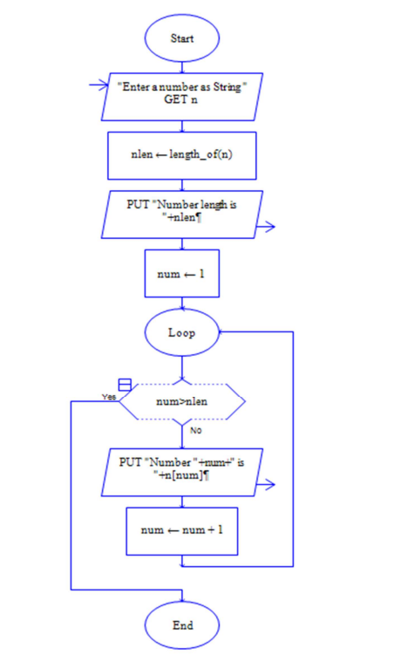

**OUTPUT**

INPUT IS VISHNU079

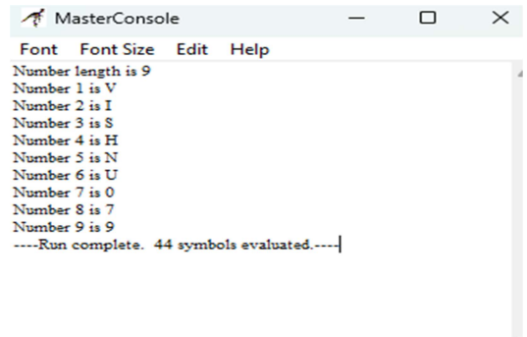

**RESULT:**

The program is executed and verified successfully